­

**12/19/2024**

Table of Contents

**Chp1. Introduction** 1

**1.1** **Problem statement** 1

**1.2** **Objectives** 1

**Chp2. Dataset** 2

**2.1** **Description** 2

**2.2** **Dataset #1 : Facial Expressions Training Data** [2] 2

**2.2.1** **Description** 2

**2.2.2** **Samples** 2

2

**2.3** **Dataset #2 : Binary classification dataset of Happy or Sad img.** [3] 3

**2.3.1** **Description** 3

**2.3.2** **Samples** 3

Test for motasem 4

Secondary title 4

Secondary title again 4

References 5

Table of Figures

Figure 1six random image sample of the dataset Facial Expressions Training Data. 2

Figure 2 six images of the category showcasing the outliers in the dataset that needs to be preprocessed before starting 3

Figure 3 a duck very bad 5

|  |  |
| --- | --- |
| **Table of abbreviations** | |
| **Abbreviation** | **Stand for** |
| KNN | **K-Nearest Neighbors** |
| SVM | **Support Vector Machines** |
| PY | **Python** |
| RM | **Rapid Miner** |

## **Chp1. Introduction**

* 1. **Problem statement**

“In 2009 Egypt was ranked 15th in global retailing (Consumer Quality, Customer Satisfaction, and Store Loyalty)” [1]. Customer Satisfaction plays a major role in market sales and profit gaining. We think that a happy customer is a smiling customer. And we would rate each customer by the face emotions and expressions analyzed using Deep Learning CNN models for the faces of the customers. The most affecting factor for customer satisfaction and happiness in a market or a supermarket is the cashier, or who is there for servicing them. So, we thought about a competitive method for all the staff team to compute about. Each staff member will be rated depending on how much time a customer smiles while they are together.

* 1. **Objectives**

Generating a friendly and competitive environment using Deep Learning model and simple web interfaces to calculate how much time the customer spent with the staff member X smiling. The main objective is detecting the happy face expression as the flag that starts the count for more points to the staff member.

## **Chp2. Dataset**

1. 1. **Description**

Clear images of normal human faces with a sharp visible expression were the perfect description of a dataset. We used two datasets to have the best effect for and to test on a clean data for accurate and precise results. While also training on noisy and monochromatic images.

* 1. **Dataset #1 : Facial Expressions Training Data** [2]
     1. **Description**

“Processed for a Neural NetworkAffectNet is a large database of faces labeled by "affects" (psychological term for facial expressions). In order to accommodate common memory constraints, the resolution was reduced down to 96x96. Meaning that all images are exactly 96x96 pixels.

No Monochromatic ImagesUsing Singular Value Decomposition, each image's Principal Component Analysis was calculated. The threshold for the "percentage of the first component (index 0) in the principal components" (in short the PFC%) was set to lower than 90%. This means that most if not all of the monochromatic images were filtered out.The PFC% was left inside the CSV file, should you prefer a lower PFC% threshold.” [2] This data-set is based on AffectNet-HQ, which used a state-of-the-art FER model to improve the on the AffectNet original labels. There are eight classes anger, contempt, disgust, fear, happy, neutral, sad, and surprise. There is approximately total of 30K image.

* + 1. **Samples**

This is an example random sample of the dataset

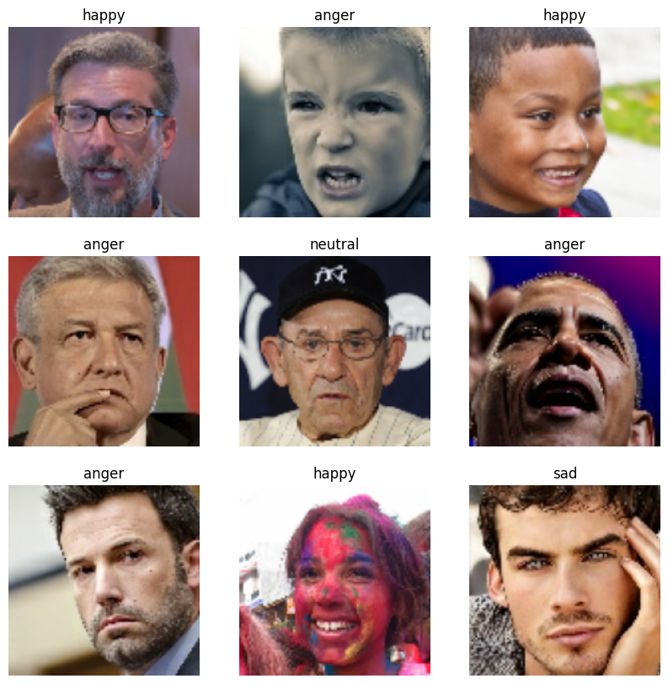

Figure 1six random image sample of the dataset Facial Expressions Training Data.

* 1. **Dataset #2 : Binary classification dataset of Happy or Sad img.** [3]
     1. **Description**

“This dataset contains labeled examples for binary emotion classification, focusing on two distinct classes: Happy and Sad. The dataset is designed for training and testing machine learning models that can differentiate between positive and negative emotional states. Dataset Structure. The dataset is divided into two classes: Happy, Representing positive emotional expressions. Sad, Representing negative emotional expressions. Number of samples in the dataset contains an unbalanced number of samples for each class. File Format: The data is provided in [mention file format, e.g., JPG, etc.]. Applications This dataset is ideal for various applications, including but not limited to: Sentiment Analysis: Developing models based on emotional content. Facial Expression Recognition: Training models to recognize and differentiate between happy and sad facial expressions.” [3] This dataset is aproxmitly 1500 sample. The dataset has some mijor problems. Some pictures are not humans (emojis, anime, etc…) and some are humans but not facing the camera, or they might be fully or partialy covering the face.

* + 1. **Samples**

This is an example random sample of the dataset

Figure 2 six images of the category showcasing the outliers in the dataset that needs to be preprocessed before starting

# Test for motasem

## Secondary title

Fsjadhfjksadhflaksjdh fsdahflsdahflh sdlafhadsl

Fdajksl fjksadhf lsadf dsf sdajkfh asdjkhf asdf

Shafh

Sahdf jsahfsah

Fsa [4]

## Omar Farouq

Sadfkadsljfkl asdhfasdhfklashfjashfjkl

### Testing for food

## Secondary title again

## 

Figure 3 a duck very bad

# References

|  |  |
| --- | --- |
| [1] | O. Ramzy, "The Egyptian Retailing Industry," *Heliopolis University,* p. 16, 2020. |
| [2] | N. Segal, "kaggle," 2022. [Online]. Available: https://www.kaggle.com/datasets/noamsegal/affectnet-training-data. [Accessed 19 12 2024]. |
| [3] | Sam, "Kaggle," 8 2024. [Online]. Available: https://www.kaggle.com/datasets/shamstabrezkhan/happy-and-sad-images-dataset-for-cnn. [Accessed 9 12 2024]. |
| [4] | A. Tolba, "github," motasem, 2 6 2016. [Online]. Available: https://meet.google.com/qbb-xvjb-eow. [Accessed 20 12 2024]. |